**COUNTING NUMBER OF ENTRIES:**

SELECT count(*) AS TOTAL_ENTRIES FROM car_dekho;

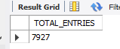

**TOTAL NUMBER OF CARS AVAILABLE IN 2023:**

SELECT count(*) as available_cars_in_2023 from car_dekho

where year = "2023"

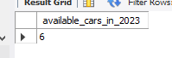

**AVAILABLE CARS IN 2021,2022,2020:**

**1)** SELECT COUNT(*) AS CARS_2020 FROM CAR_DEKHO

WHERE YEAR= "2020"

**2)** SELECT COUNT(*) AS CARS_2021 FROM CAR_DEKHO

WHERE YEAR= "2021"

**3)** SELECT COUNT(*) AS CARS_2022 FROM CAR_DEKHO

WHERE YEAR= "2022"

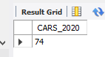 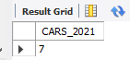 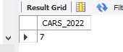

**OR**

**USING GROUP BY CLAUSE**

SELECT COUNT(*) AS RESPECTIVE_YEARS FROM CAR_DEKHO WHERE YEAR IN (2020,2021,2022) GROUP BY (year)

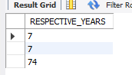

**TOTAL CARS AVAILABLE IN ALL THE YEARS:**

SELECT YEAR , COUNT(*) AS TOTAL FROM CAR_DEKHO

GROUP BY YEAR

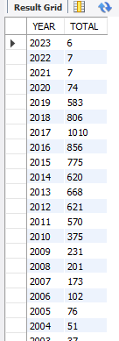

**DIESEL CARS IN 2020:**

SELECT count(*)total_diesel_engine, fuel from car_dekho

where fuel = "Diesel" and year = "2020"

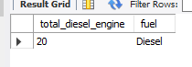

**PETRO CARS IN 2020;**

SELECT count(*)total_petrol_engine, fuel from car_dekho

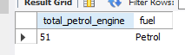where fuel = "Petrol" and year = "2020"

**TOTAL CARS OF PETROL , DIESEL , CNG;**

SELECT YEAR , COUNT(*) AS PETROL FROM CAR_DEKHO WHERE FUEL = "PETROL" group by YEAR;

SELECT YEAR , COUNT(*) AS DIESEL FROM CAR_DEKHO WHERE FUEL = "DIESEL" group by YEAR;

SELECT YEAR , COUNT(*) AS CNG FROM CAR_DEKHO WHERE FUEL = "CNG" group by YEAR;

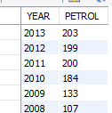 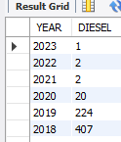 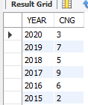

**YEARS HAVING TOTAL NUMBER OF CARS MORE THAN 500:**

SELECT YEAR, COUNT(*) FROM CAR_DEKHO

GROUP BY YEAR HAVING COUNT(*)> 500

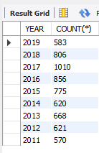

**NUMBER OF CARS BETWEEN 2015-2020 AND WITH COMPLETE LIST:**

SELECT NAME , FUEL , OWNER,YEAR FROM CAR_DEKHO

WHERE YEAR BETWEEN 2015 AND 2020

